Smart Meter Reading & Billing System

Project Overview
The Smart Meter Reading and Billing System efficiently collects, processes, and visualizes electricity consumption from smart meters in real time. It aggregates meter readings daily, weekly, and monthly, automatically calculating total energy usage and bills. A live meter dashboard using Server-Sent Events (SSE) allows users to monitor real-time consumption, receive alerts for excessive usage, and view detailed meter information. This project provides a complete energy management solution that enhances accuracy, user experience, and efficient monitoring of smart energy systems.
Technical Stack:
- Backend: Java, Spring Boot, Hibernate, JPA, RestTemplate, Kafka
- Database: PostgreSQL
- Frontend: React.js with live data visualization
- Deployment: Docker Compose for multi-service orchestration (Postgres, Kafka, Zookeeper, Microservices)

High Level Design (HLD)
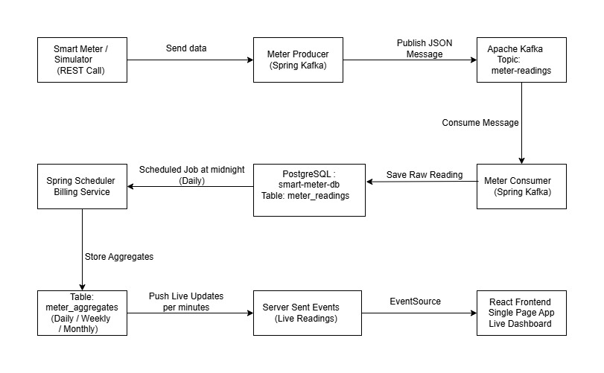

The system follows an event-driven architecture where smart meter readings are ingested via REST APIs, published to Kafka, processed asynchronously, and streamed to the frontend in real time using Server-Sent Events (SSE). This ensures scalability, loose coupling, and real-time UI updates without polling.

Low Level Design (LLD)

Step 1: Smart Meter Reading Generation
- Smart meters continuously collect electricity consumption data.
- Each meter generates readings containing:
  - meterId
  - timestamp
  - units
- The generated reading is published to the Kafka topic meter-readings.

Step 2: Smart Meter Microservice (Kafka Consumer)
- The Smart Meter microservice consumes readings from Kafka.
- For each incoming reading:
  - IF the reading is valid
    - Save the reading into the meter_readings database table
  - ELSE
    - Skip the reading and log an error message

Step 3: Scheduled Aggregation Process
- A scheduler runs periodically (every midnight).
- The scheduler triggers:
  - Daily aggregation
  - Weekly aggregation
  - Monthly aggregation

Step 4: Daily Aggregation
- Fetch all meter readings for the current day.
- For each meterId:
  - Sum total units consumed
  - Calculate bill using:
totalBill = totalUnits × UNIT_RATE
  - Round totalUnits and totalBill to 2 decimal places
  - Store results in meter_aggregates table with:
    - type = DAILY
    - date = today

Step 5: Weekly Aggregation
- Fetch all meter readings from the last 7 days.
- For each meterId:
  - Sum total units
  - Calculate bill
  - Round calculated values
  - Store results in meter_aggregates table with:
    - type = WEEKLY
    - date = startDate to endDate

Step 6: Monthly Aggregation
- Fetch all meter readings for the current month.
- For each meterId:
  - Sum total units
  - Calculate bill
  - Round calculated values
  - Store results in meter_aggregates table with:
    - type = MONTHLY
    - date = startDate to endDate

Step 7: Live Meter Updates using SSE
- When the user opens the dashboard, the frontend connects to:
/stream/meter-updates
- Every minute:
  - Fetch daily, weekly, and monthly aggregates
  - Compute summary totals
  - Fetch today’s live meter readings
  - Send updated data to the frontend using Server-Sent Events (SSE)
  - IF any total bill exceeds the defined threshold
    - Display an alert on the dashboard

Step 8: Frontend Dashboard Display
- Display summary cards for:
  - Daily usage
  - Weekly usage
  - Monthly usage
- Display live meters table with:
  - meterId
  - totalUnits
  - totalBill
  - timestamp
- IF the user clicks on a meter card:
  - Show detailed meter information
- IF totalBill exceeds threshold:
  - Show alert using color change or animation

Step 9: User Interaction
- User can manually refresh the dashboard.
- All data updates automatically every minute via SSE.

Step 10: API Testing & Validation
- Open PostgreSQL databases using pgAdmin:
http://localhost:5050/browser/
  - Username: postgres
  - Password: Shahneela@123
- Create the following databases:
  - smart_meter_db
  - smart_meter_agregrate
- Tables are created automatically:
  - meter_readings in smart_meter_db
  - meter_aggregates in smart_meter_agregrate
- Send meter readings using:
  - POST http://localhost:8080/meter/send
Example:
{
"meterId": "MTR-101",
"timestamp": "2025-12-15T01:28:00",
"units": 20
}
- Retrieve readings using:
  - GET http://localhost:8080/meter/readings
- Aggregated results can be verified via:
  - GET http://localhost:8081/aggregates
- Live meter updates can be tested using:
  - http://localhost:8081/stream/meter-updates

